# DriverPass System Design

## UML Diagrams

### UML Use Case Diagram

**I could not keep adding more stuff because Lucid chart would have made me purchase a premium account. I used a different program for the remaining sections that did not have limitations. There should be a generalization arrow from both "online" and "offline" pointing to "download data"

I would have liked to be able to break off the administration into different actors, but again, I was not going to pay for a premium account.

It starts off with the customer, who ideally would have been broken off into a new customer and returning. If I could have divided them up, I could have had a few different relationships and a few more use cases. For example, a new customer would have a relationship with creating an account filling out their information and purchasing a DriverPass package. While with the returning customer, they would have a relationship with login, access content, etc.**

### UML Activity Diagrams

### UML Sequence Diagram

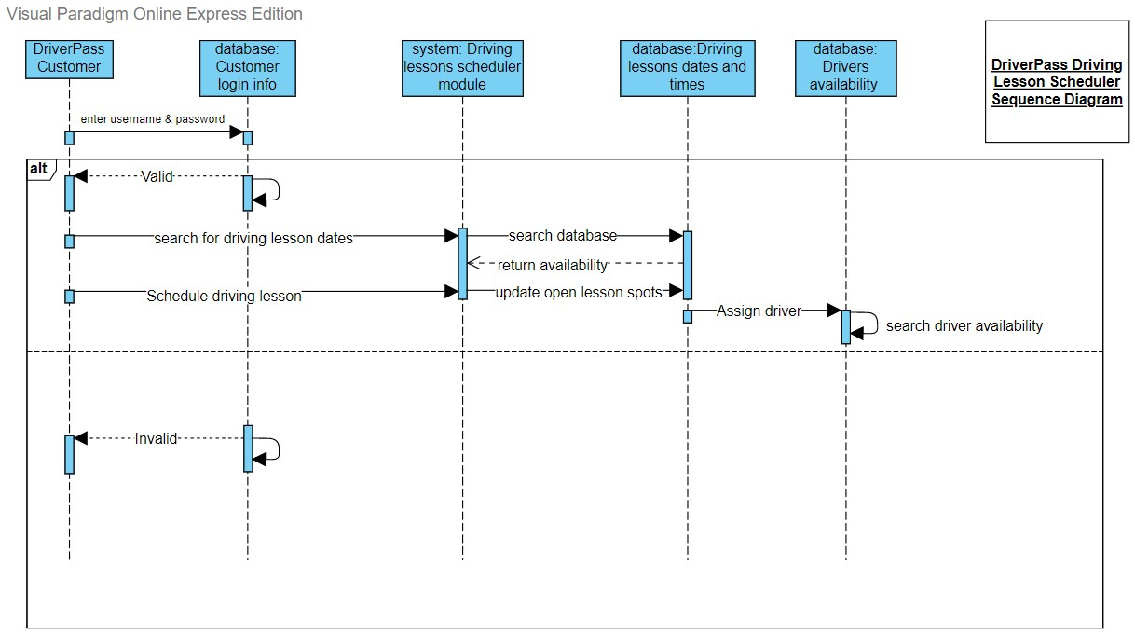

### UML Class Diagram

## Technical Requirements

I would recommend that DriverPass goes with Windows for their operating platform. Not only is Windows compatible with nearly all types of software, but their computers are also ready to be used right out of the box. All of computers relate to an active directory that can be configured by Liam. This will be useful so that he will be able to control and monitor who has access to what.

Windows architecture is designed for superior performance. Windows NT (New Technology) has a layered system of modules which consist of: Hardware-Abstraction Layer, Kernel, and the Executive. This allows it to have two different modes: User Mode and Kernel Mode. In short, User Mode is where applications are being ran and Kernel Mode is how the applications can access the hardware. Many of the core applications that will be used are already windows-based applications. Win32 is the Windows application programming interface (API) will allow for the developers to take advantage of all the capabilities and features that each API category has.

Windows does a nice job at organization on its system when it comes to the storage of data. There is an API specifically for data access and storage. Within here, Windows OS has a wide range for how it deals with management storage, from external drives such as the One Drive which is stored in the cloud or simple storage methods such as single-disk desktops. The GUI makes it easy to manage and sift through all the data. There are also built-in functions, such as Storage Sense, that lets Windows automatically pick out old files that have not been used, emptying the recycle bin & downloads folder, to name a few of the ways Windows can help free-up storage. This can help DriverPass with keeping all their data from their customers and new laws at the DMV updated and remove all the old clients or old driving law data.

All computers that run on a Windows’ OS come preinstalled with security features such as malware protection, firewall & network protection, and device security features such as facial recognition software. The corporate computers that will be given out can also be accessed remotely to erase, shut down, and lock any computer if it were to be stolen or misplaced. Most of these Window OS computers will be accessing data from within Microsoft’s cloud services. All this data will be encrypted, whether it be stationary on the computer or being transferred from the server. The Federal Information Processing Standards is one of the many components of the Microsoft Security Policy. Using this standard as an example, Microsoft uses cryptographic resources, that are already included within the Windows OS, to run certificates and authentication methods. Microsoft’s cloud platform is Azure, and it includes a multitude of encryption methods for protecting the various amounts of data types, both in transit and not.